SiniGrind: GANTT Chart
1. List the tasks
- Database Schema & Setup
- Wireframes & UI Prototype
- Prototype Review and Feedback
(Customer - the UI/Modules on customers end)
- Landing Page
- Login Page
- Register Page
- Cart/ Place Ordering Page
- Product Page/Browse Item - displays available coffee products with deets and prices
- Client Landing (after login)
- Track-order Page - allows users to check order status
- Order History Page - displays past purchases for logged-in users
(Admin - UI/Modules on admin’s end)
- Admin Dashboard
- Sales Summary Page
- Managing Products Page
- Managing Orders Page
(Finalization)
- Integration and Testing
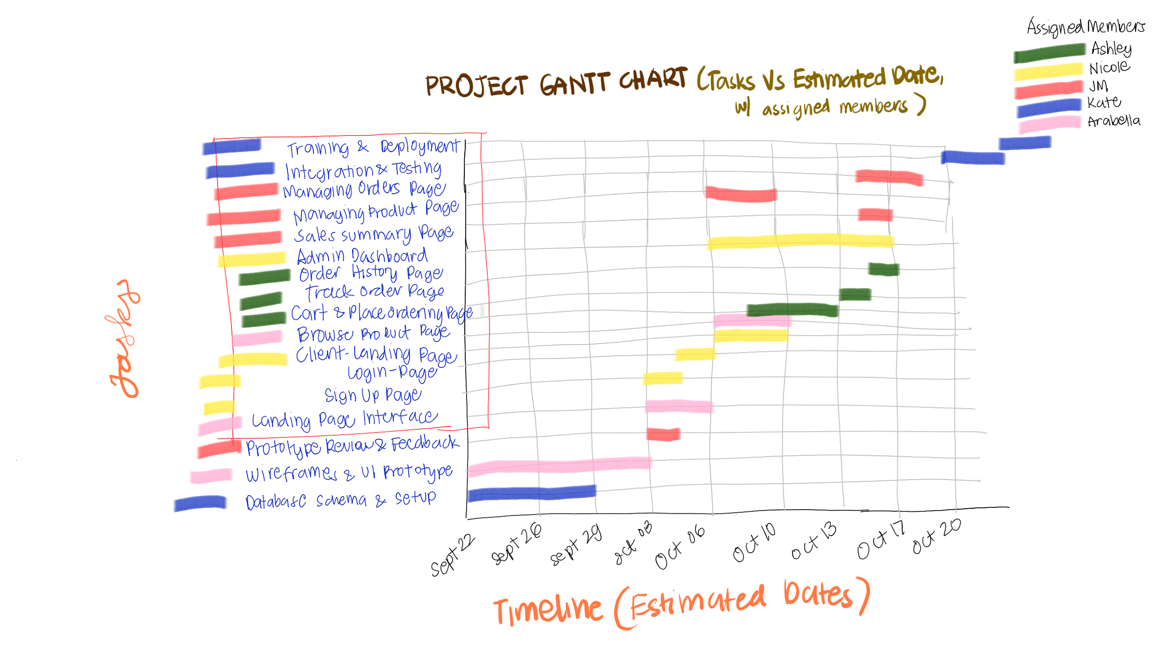
- Training and Development

